**Microsoft PowerPoint**is undoubtedly the most popular application used to give presentations. You're likely to see PowerPoint presentations being used for everything from presentations at the world's largest companies to grade schoolteachers sharing lessons.

[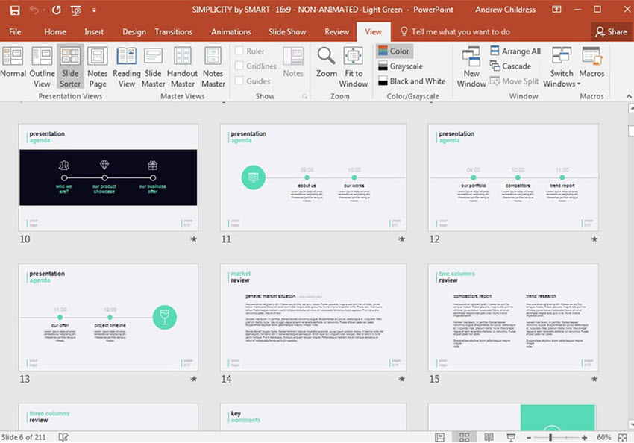](https://graphicriver.net/item/simplicity-premium-and-easy-to-edit-template/12165048).

Here are the key actions you'll need to take to build a PowerPoint presentation:

* You'll need to add **slides,**the individual pages in the presentation.
* You'll add **content**to the slides, such as text boxes, images, charts and graphs.
* Change **themes and styles**to make your presentation look professional and fit the occasion at hand.
* Prepare presentation aids like **Speaker Notes**and **Presenter View**to help you feel comfortable with presenting.

**How to Use PowerPoint's Ribbon**

**1. The Ribbon**

The ribbon menu is found across many of Microsoft's apps, such as Word, Excel, and PowerPoint. It lives above the main area of the application.

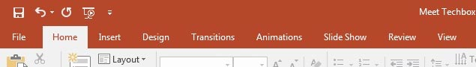The PowerPoint ribbon lets you switch between various tabs.

The ribbon contains a series of tabs that you can switch between. Each of these has a unique set of tools to work with your presentation differently. When you switch tabs on the ribbon, you'll see new buttons and options to change your presentation:

* **File**. Save, share, and export your presentation.
* **Home**. A general-purpose collection of the most common tools that you'll use in PowerPoint.
* **Insert**. An all-in-one tool to add every imagine-able type of content, such as tables, pictures, charts, video, and more.
* **Design**. Controls the look and feel of your presentation with theme and style settings.
* **Transitions**. Add animations when you switch slides.
* **Animations**. Controls the order and style that objects will enter or exit your slide with.
* **Slide Show**. Control settings related to the way your presentation appears when sharing it with an audience.

Now that you understand the layout, you've got a better idea of how you can jump to the feature you need. Let's dive a bit deeper into how you can use several of these key tabs.

**2. The Home Tab**

***Use it for:****a general selection of the most popular tools in PowerPoint.*

I usually stay on the **Home** tab when I'm working in PowerPoint. The reason is because it's got practically every tool you need. From adding a new slide to changing text and paragraph settings, the **Home** tab is the default for most users.

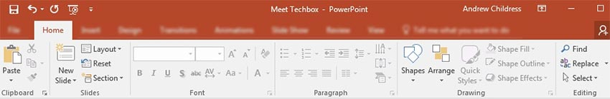The **Home** tab has many of the most used tools, all in one bar.

**3. The Insert Tab**

When you're working on adding content to a slide, the **Insert**tab has every possible tool to add new content to a slide. Choose one of these types of objects to add it to the slide.

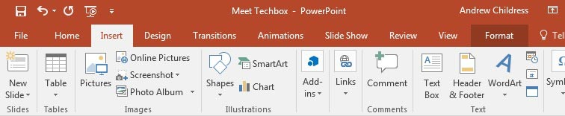The**Insert**tab has the tools you need to add tables, pictures, charts, and more.

**4. Views**

PowerPoint has a variety of views that are simply different ways to work with the same presentation. Change the view to get a different perspective on your content.

Use views for a different way to edit and build your PowerPoint presentation.

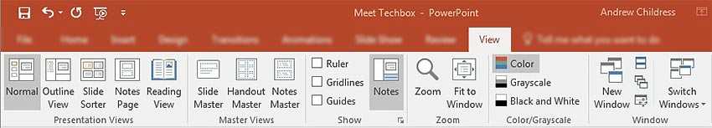The **Views** tab changes the perspective on your PowerPoint presentation.

In the screenshot below, you can see the difference between the default **Normal**view and **Slide Sorter**view.**Normal**view shows each slide front and center. **Slide Sorter** view creates thumbnails that you can drag and drop to reorder the presentation.

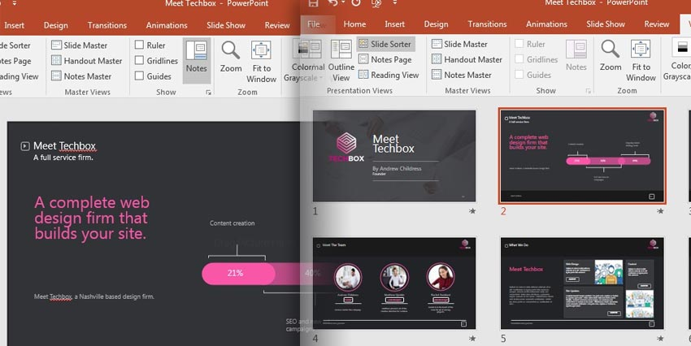**Normal** view is the default presentation view in PowerPoint. An alternate view like **Slide Sorter** allows you to re-sequence your presentation by dragging and dropping the slide thumbnails.

**5. The Design Tab**

An attractive presentation can really grab your audience's attention. We use themes and styles in PowerPoint to add visual appeal to the presentation, and the **Design**tab really controls these settings.

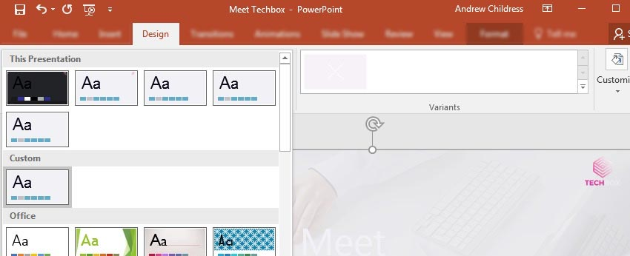Click on one of the theme thumbnails to transform the look and feel of the presentation.

On the **Design** tab, click one of the themes to restyle the presentation. Or, try out a different Style thumbnail to overhaul the color theme.

**The Steps to Create a PowerPoint Presentation**

**1. How to Add Slides**

Think of **slides**as the individual units in your presentation that you can fill with content. To insert a new slide, go to the **Insert**tab on PowerPoint's ribbon. Then, click on the **New Slide**button to add a new slide to your presentation.

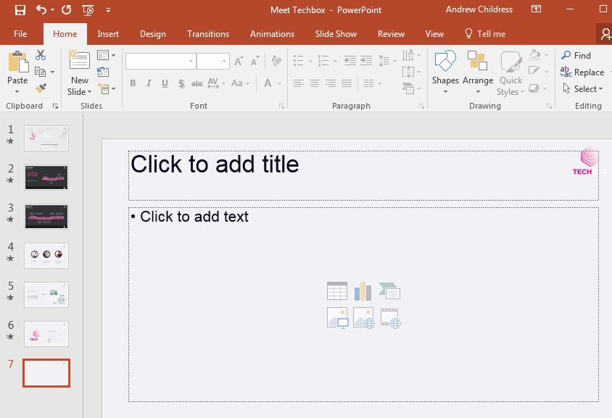

A new slide will have basic placeholders to add your content to in PowerPoint.

Each of the thumbnails that you'll see on the sidebar represents a slide. Then, you'll add content to each slide.

There's no practical limit to the number of slides that your PowerPoint file can contain. But you should consider how many slides it actually takes to make your point. It's often the

**Step by Step to create a presentation**

* Open PowerPoint.
* Select an option:
  + Select **Blank Presentation** to create a presentation from scratch.
  + Select one of the templates.
  + Select **Take a Tour**, and then select **Create**, to see tips for using PowerPoint.

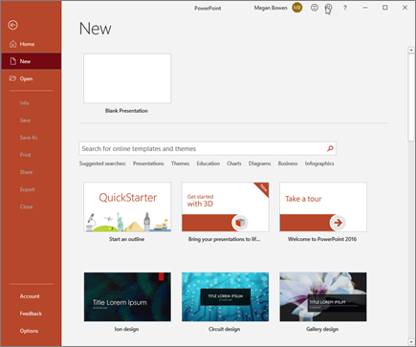

**Add a slide**

1. Select the slide you want your new slide to follow.
2. Select **Home** > **New Slide**.
3. Select **Layout** and the you type want from the drop-down.

**2. How to Add Content**

Content is what defines each slide. PowerPoint accommodates a wide range of content like text, graphs, tables, charts, and more.

The easiest way to add content is to start off by choosing a **Layout,**which you can choose from the **Home**tab.

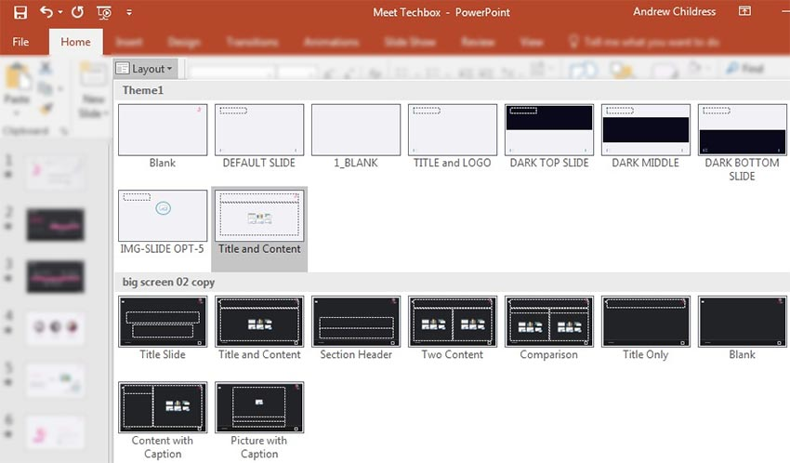

Various Power Point layouts shown on the **Home**tab.

These layouts have content boxes that are easy to add your own content to. Simply choose a layout, and then start adding your content.

**3. How to Choose a Theme and Style**

After you build out your presentation's content, it's a great idea to think about adding visual style. For this, you'll jump over to the **Design**tab, and click on one of the thumbnails for a theme.

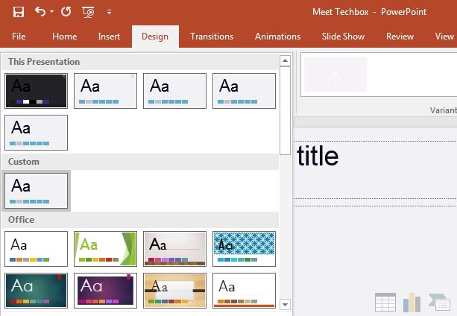

Use the **Design** tab to pick a theme.

Using a PowerPoint theme is the preferred alternative to adding backgrounds, color and type styles to each slide. Changing the theme typically will adjust the entire presentation simultaneously. This greatly reduces the time involved with building a presentation.

With just these three steps, you've got the repeatable sequence of actions needed to build a presentation.

**Save presentation to online drive**

When you save your files to the cloud, you can share and collaborate with others, and get to your files from anywhere - on your computer, tablet, or phone.

* Select File > Save As.
* Select OneDrive.

Save personal files to OneDrive - Personal, and work files to your company OneDrive. You can also save to another location, like your device.

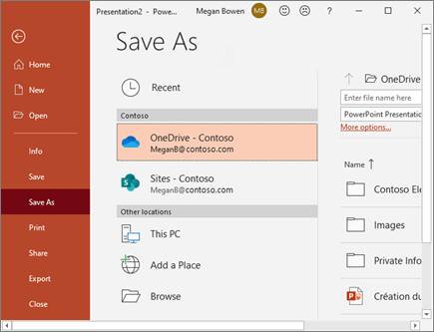

**Rename a presentation**

1. Select the file name on the title bar.
2. In the menu that appears you can rename the file, select a new location to move it to, or see the version history for the file.

**Use PowerPoint Designer**

* Insert one or more pictures, a list of items, or a list of dates.
* The **Designer**panel will open. Select the design you want.

You can also bring up Designer by selecting a picture, and then selecting **Design**> **Design Ideas**.

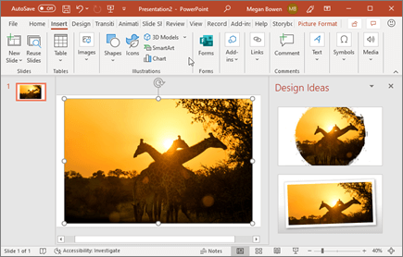

**Transitions**

To add a special effect, to transition from one slide to another:

* Select the slide you want to add a transition to.
* On the **Transitions** tab, select the effect you want.
* Select **Effect Options** to change how the transition happens: **From Right**, **From Left**, ...

To undo a transition, select **None**.

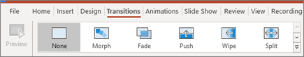

**Animations**

To animate text or objects on a slide:

1. Select the text or object you want to animate.
2. On the **Animations** tab, select **Add Animation**, and select the animation you want from the drop-down.

To animate one line of text at a time, select one line of text, select an animation, select the next line of text, select an animation, ...

1. For **Start**, select **When Clicked**, **With Previous**, or **After Previous**.

You can also select the **Duration** or **Delay**.

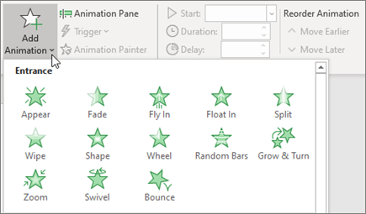

**Start a presentation**

* On the **Slide Show** tab select **From Beginning**. Now, if you are working with PowerPoint on a single monitor and you want to display Presenter view, in **Slide Show** view, on the control bar at the bottom left select the three dots, and then **Show Presenter View**.
* To move to the previous or next slide, select **Previous** or **Next**.
* To view all the slides in your presentation, select **See all slides**.

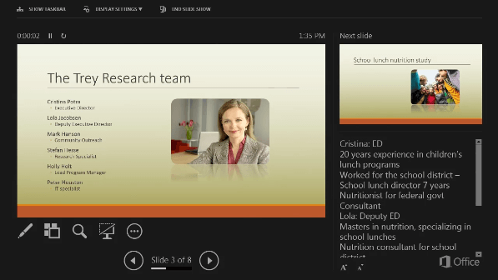

**Notes**

During your presentation, the speaker notes are visible on your monitor, but aren't visible to the audience.

* The Notes pane is a box that appears below each slide. Tap it to add notes.
* If you don’t see the Notes pane or it is completely minimized, click **Notes** on the task bar across the bottom of the PowerPoint window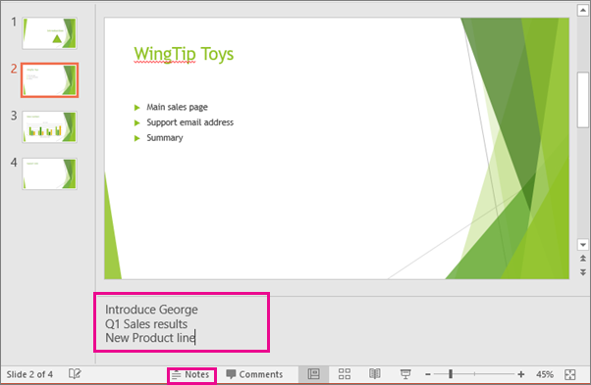

**Subtitles**

You can choose which language the caption/subtitle text should be shown to your audience. This feature requires Windows 10 and an up-to-date version of PowerPoint.

* Select **Slide Show** > **Subtitle Settings**.
* Set your **Spoken Language**.
* Select **Subtitle Language** to see which languages PowerPoint can display on-screen as captions or subtitles, and select the one you want.
* In the **Subtitle Settings** menu, set the desired position of the captions or subtitles.
* More appearance settings are available by selecting **Subtitle Settings** > **More Settings**

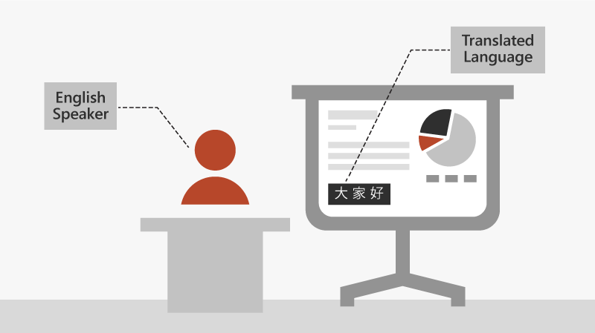

**Add Your Own Text**

The PowerPoint basics include text and images. Adding custom text is one of the easiest and most common edits to make.

[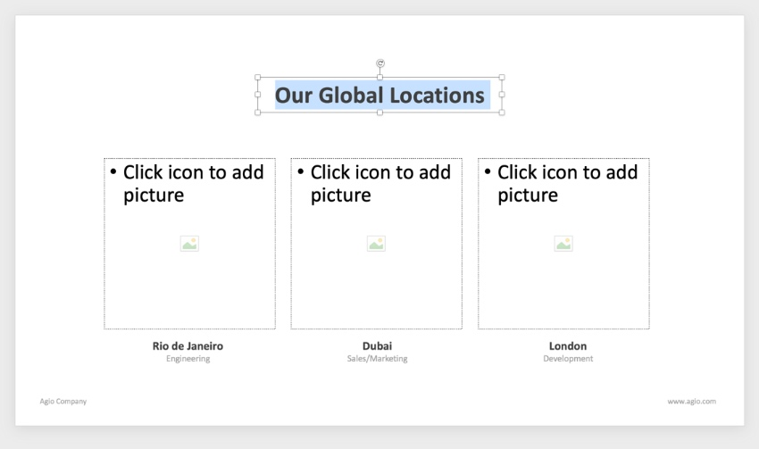](https://elements.envato.com/agio-powerpoint-presentation-BDQYP4)

Learning how to create a PowerPoint presentation for beginners involves typing over simple text placeholders like these.

**Change Object Colors**

To get started, click on a chart section to select it. On the **Format** tab, click on the**Shape Fill** dropdown. You’ll see a color chooser, from which you can apply any color imaginable.

[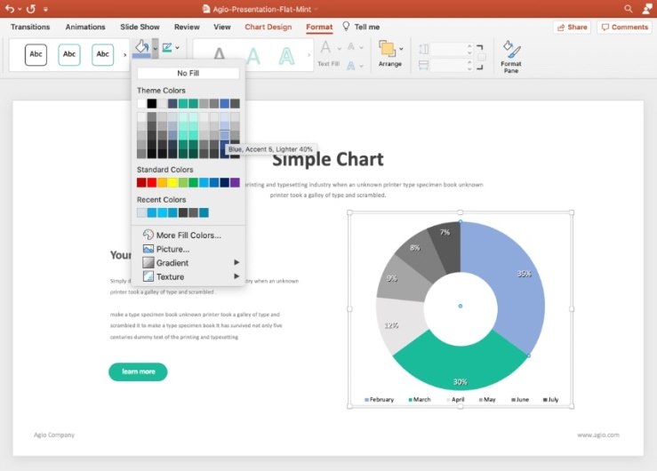](https://elements.envato.com/agio-powerpoint-presentation-BDQYP4)

One of the most important PowerPoint basics is using the **Shape Fill**dropdown to update the color scheme.

**Customize Fonts**

Highlight a block of text, then go up to the**Font** section of the **Home** tab. You’ll see dropdowns to change the font style, size, and color. After that, add quick effects like bold letters, italics, and more!

[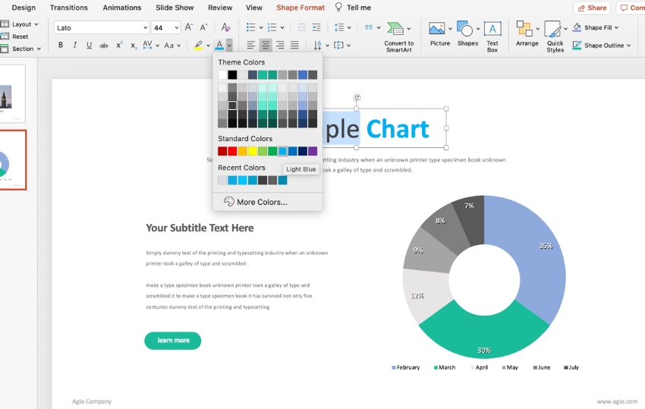](https://elements.envato.com/agio-powerpoint-presentation-BDQYP4)The **Font**menu holds all the tools you need to customize your text to match your brand.

**Presenter View**

Turn on Presenter View from the slideshow tab by clicking **Use Presenter View.**

**Or Click F5**

**Spelling and Grammar Check**

To check for common spelling issues, simply jump to the **Review**tab and click **Spelling**. PowerPoint will check for the most common issues and allow you to correct them as needed.